Name:

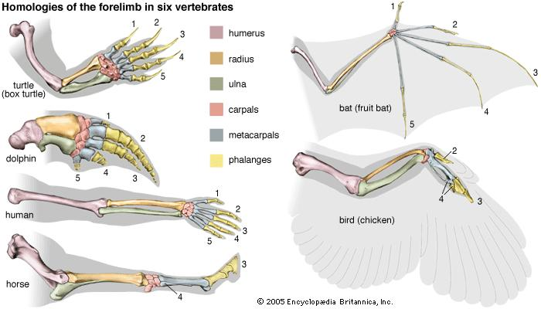

Name:

"Based on what we have discussed, and the evidence you see here, who do you think we (humans) are more closely related to, bats or chickens?" Use the CER strategy to support your answer.

"Based on what we have discussed, and the evidence you see here, who do you think we (humans) are more closely related to, bats or chickens?" Use the CER strategy to support your answer.

