**Figure 5.39**. Number of Types of Marine Animals from the Last 542 Million Years



***Figure 5.39*** *The boundaries between geologic periods that scientists have agreed upon (bottom) are often based on major extinction or diversification events when the number of genera changes quickly. Source: M. d’Alessio with data from Rohde and Muller 2005.*

**Figure 5.40**. The Timing of Major Extinction Events and Possible Causes

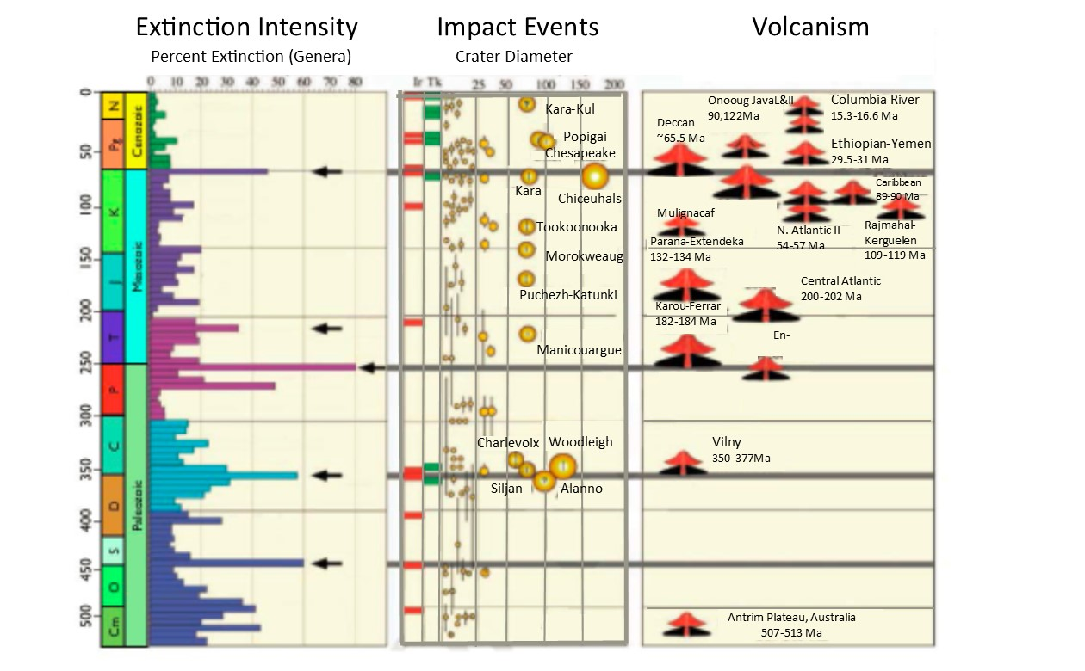

***Figure 5.40****Note that the time on the vertical axis is not at a uniform scale because of the data set used to make this figure. Each bar in the extinction intensity data set corresponds to rocks deposited during a different sub stage of geologic time. These sub stages were decided before techniques for determining the absolute age of a rock had been developed. At that time, scientists divided geologic time into different time periods based on the systematic changes they observed in the layers of rocks and fossils contained in those layers. Scientists continue to refer to these geologic time periods even though they can now describe geologic time in absolute terms (i.e., millions of years ago). Source: Modified from Keller 2011.*